Blog APP API

<https://github.com/LearnCodeWithDurgesh/Backend-Course-Blogging-Application>

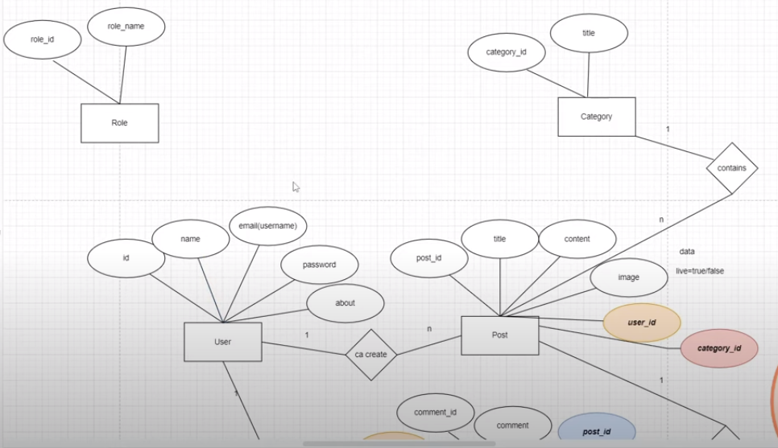

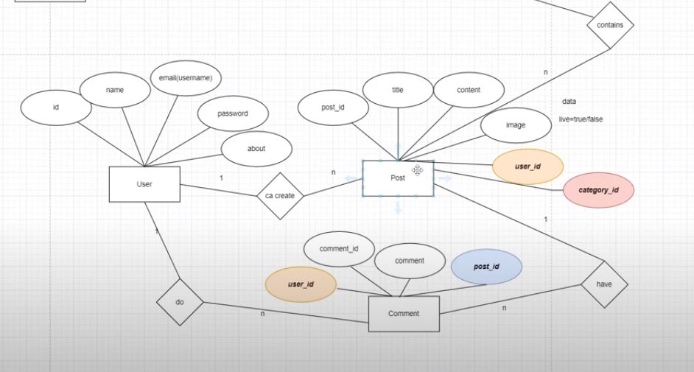

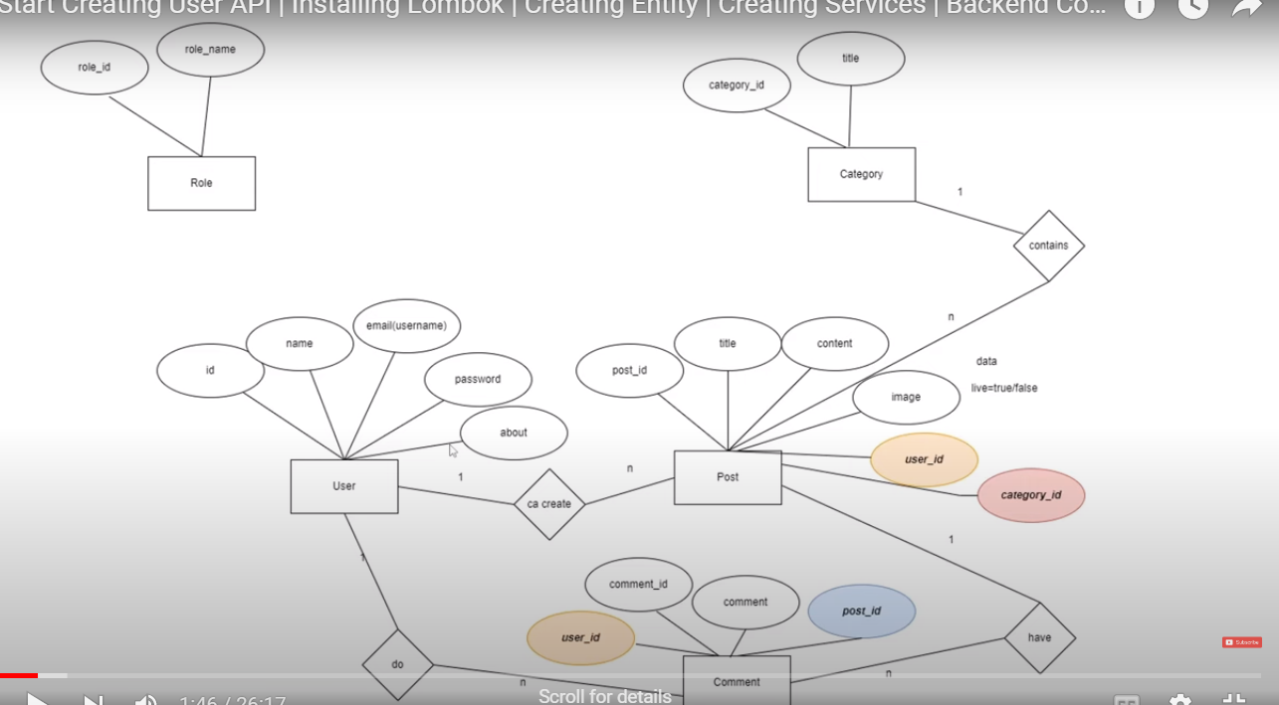

[Spring Initializr](https://start.spring.io/)

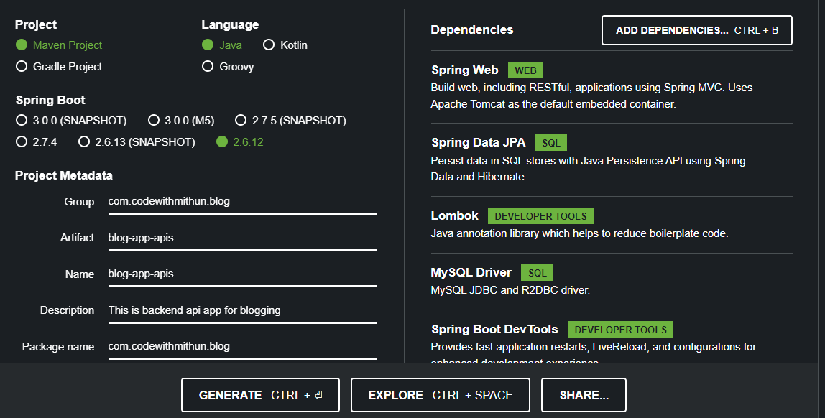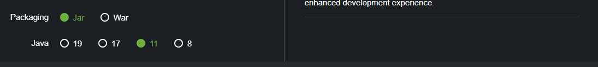

Create packages inside com.codewithmithun.blog

1. controllers

2. services

3. repositories

4.utils

5. payloads

6 exceptions

7. config

8. entities

Configure MySQL database and set port number in application.properties

server.port=9090

#DB configuration

spring.datasource.url=jdbc:mysql://localhost:3306/blog_app_apis

spring.datasource.username=root

spring.datasource.password=admin

spring.datasource.driver-class-name=com.mysql.cj.jdbc.Driver

spring.jpa.properties.hibernate.dialect=org.hibernate.dialect.MySQL8Dialect

#create, update, create-drop, validate

spring.jpa.hibernate.ddl-auto=update

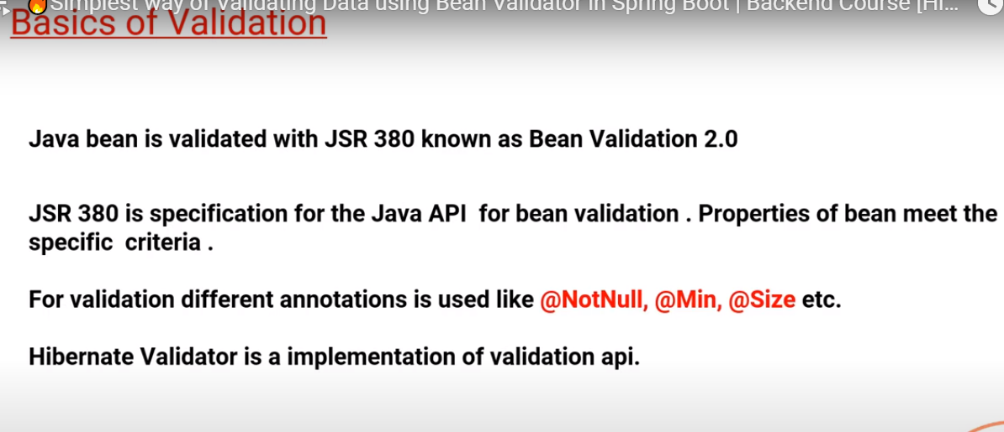

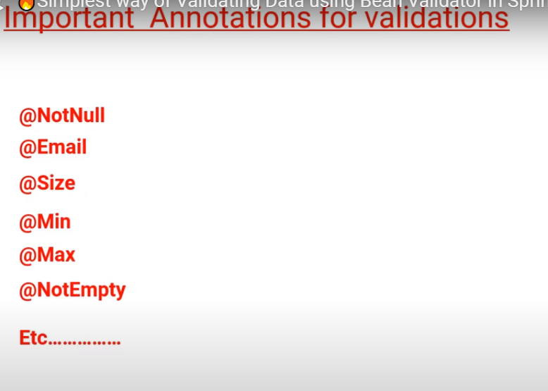

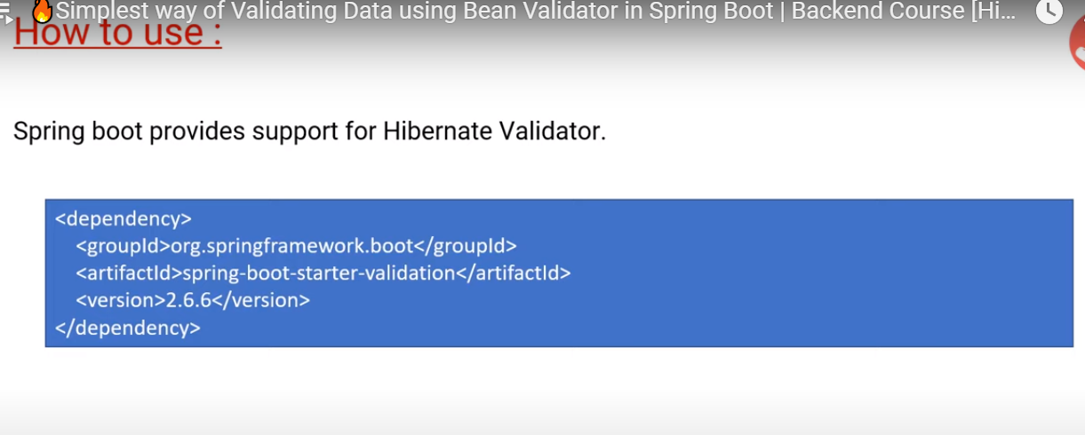

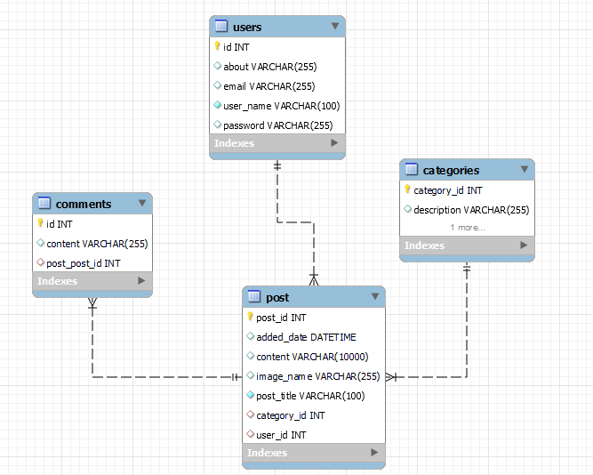

JWT

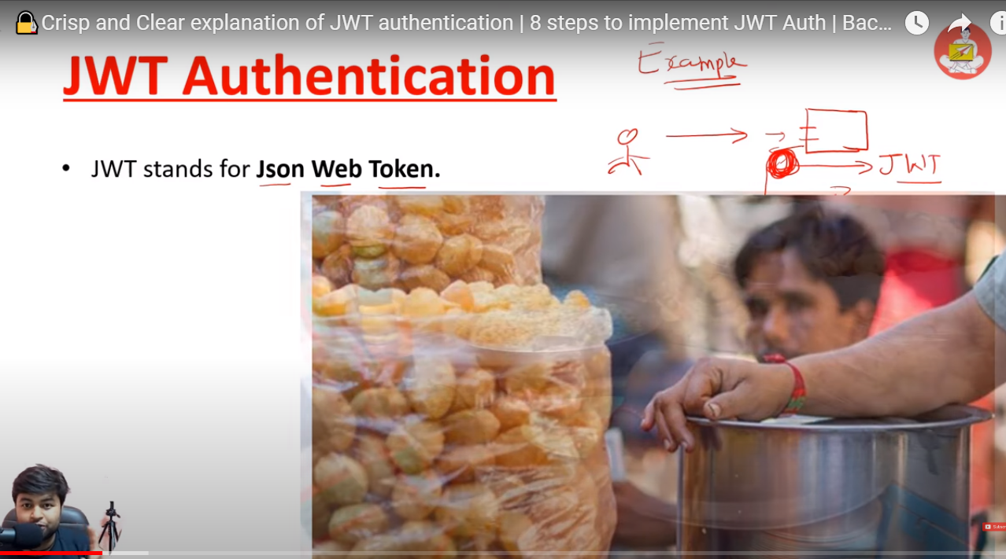

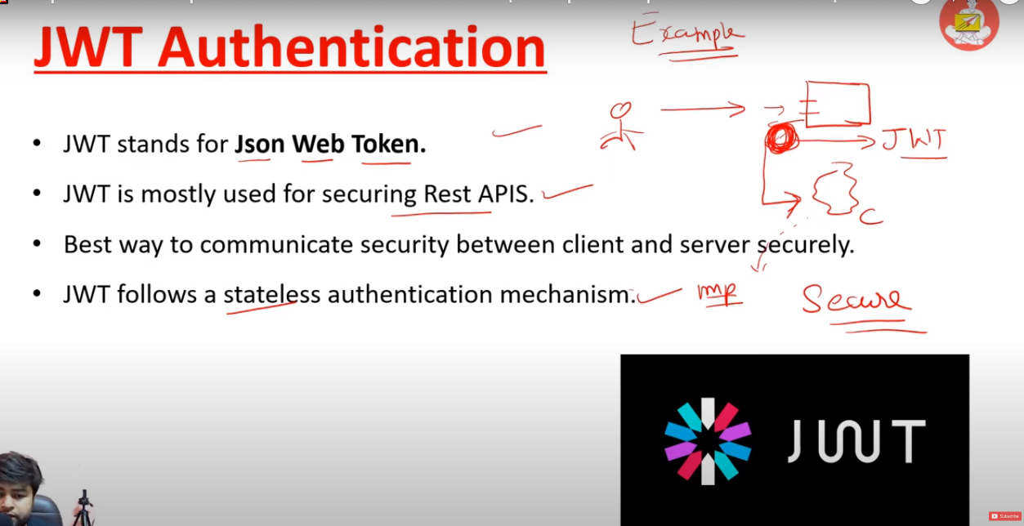

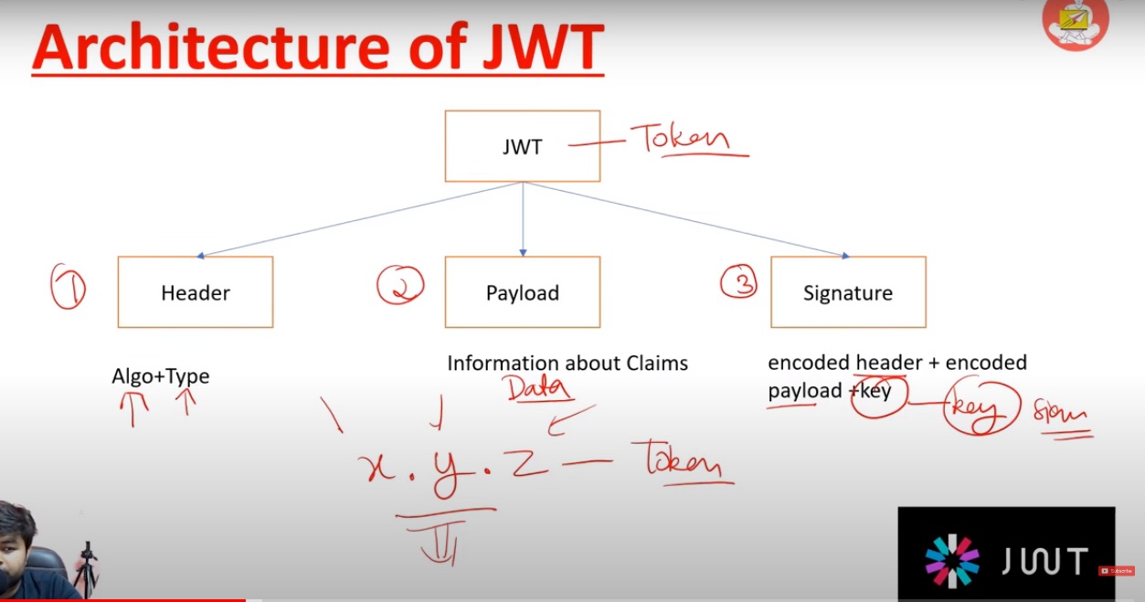

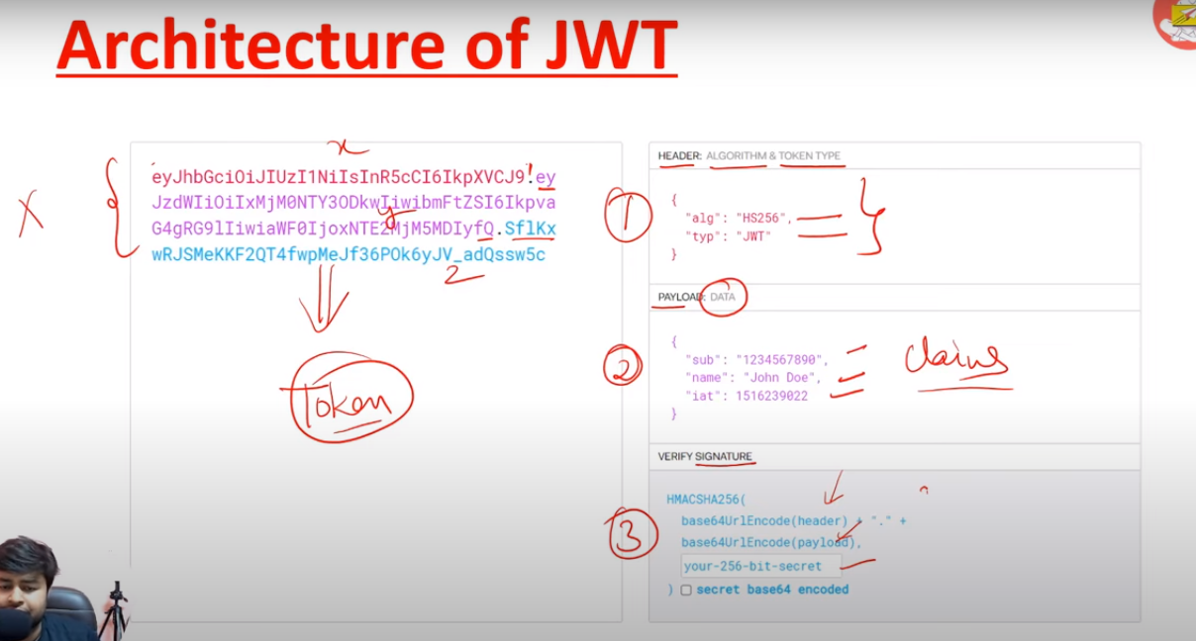

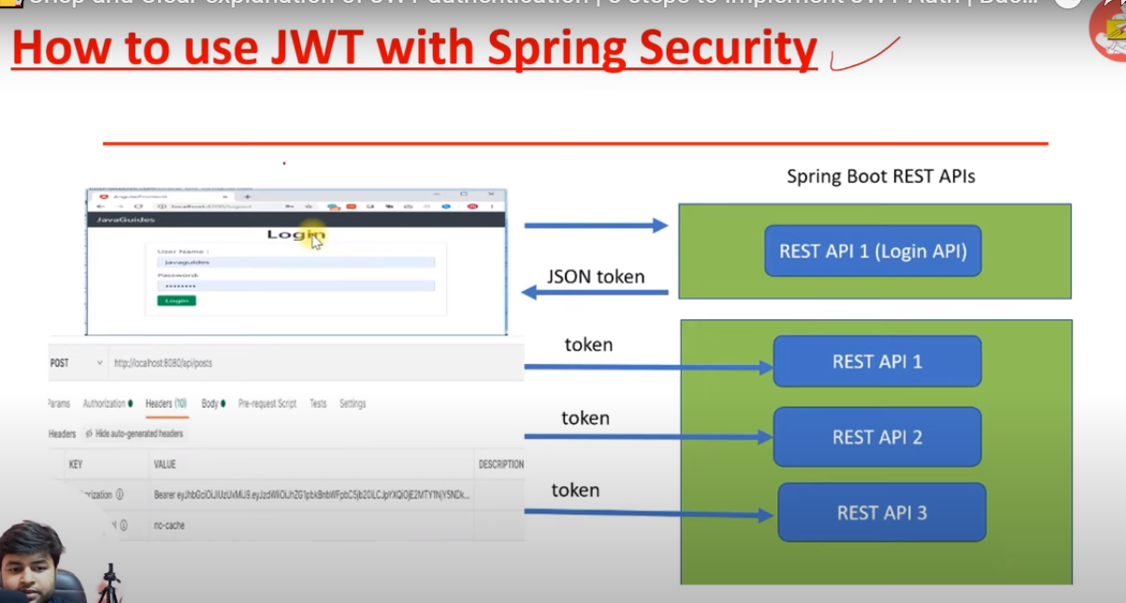

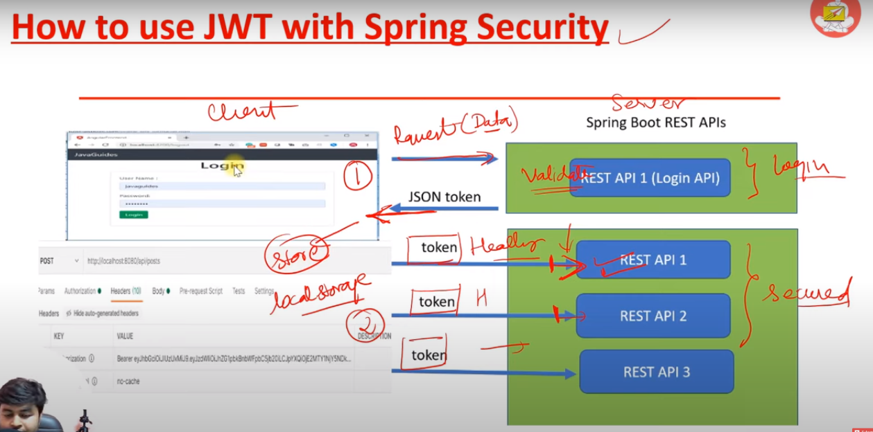

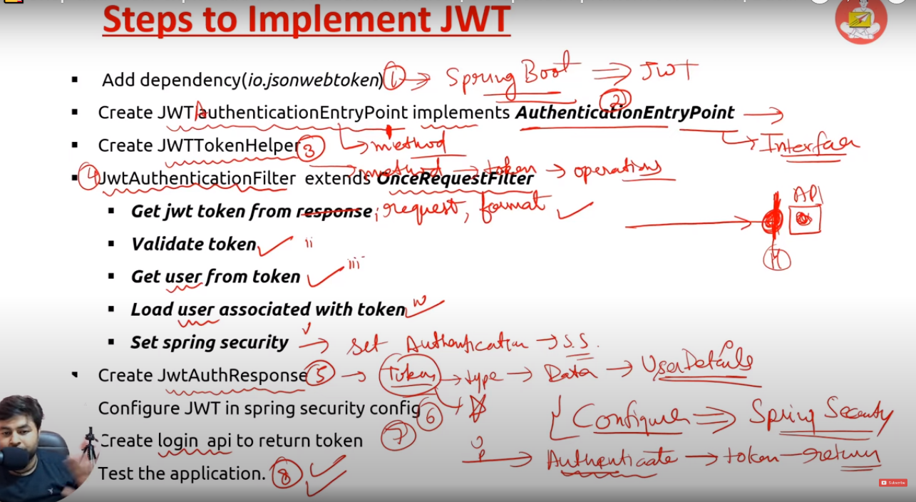

Swagger

[API Documentation & Design Tools for Teams | Swagger](https://swagger.io/)

